**Agile Project Plan Document**

|  |  |
| --- | --- |
| **Project:** | **Movie Madness** |
| Release: | 1.0 |
| Date: | April 16, 2019 |
|  |  |
| Author: | Method to the Madness |
| Owner: | DevAcademy |
| Client: | Deloitte |
| Version No.: | 1.0 |

1

|  |  |
| --- | --- |
| Project Plan - M2theM April 16, 2019 | |
| **Contents** |  |
| **1 Project Plan** | **3** |
| * 1. Purpose . . . . . . . . . . . . . . . . . . . . . . . . . . . . . .   Objectives………………………………………. | 3 |
| 1.2 Plan Description . . . . . . . . . . . . . . . . . . . . . . . . . | 3 |
| 1.3 Prerequisites . . . . . . . . . . . . . . . . . . . . . . . . . . . . | 3 |
| 1.4 Project Plan . . . . . . . . . . . . . . . . . . . . . . . . . . . . | 3 |
| 1.4.1 Quality Plan . . . . . . . . . . . . . . . . . . . . . . . | 3 |
| 1.4.2 Risk Plan . . . . . . . . . . . . . . . . . . . . . . . . . | 3 |
| 1.4.3 Acceptance Plan . . . . . . . . . . . . . . . . . . . . .     1. Project Design   2.1 Description of the project……………………………  2.2 interface and annotations……………………………   * 1. project scheduling……………………………..   2.4data modelling to demonstrate program operations   1. project testing    1. Test planning……………………………………………..    2. Test documentation…………………………………….    3. Test execution……………………………….. 2. project evaluation   4.1 Conclusion of project  4.2 How far did the project meet the specification objectives?  4.3 Further enhancements  4.4 end user feedback | 3 |

Page 2

Project Plan - M2theM April 16, 2019

# Project Plan

## Purpose

For the initial release of our project we will create a website that will be used to display the sample data within the read-only database provided, the website must have at least one dynamic page, allowing the data displayed to change depending on what the user requested. To do this we shall use a RESTful API implemented through Spring Boot and Thymeleaf to handle our back-end and the connection between server and client.

Our objectives as follows will be:

* + 1. Delivering a clear user interface for our end users
    2. Fully working code with rapid user interaction for our end users
    3. Clear and clean code for our end users
    4. Efficient and secure code produced.

## Plan Description

There are two halves of the initial project to be worked upon. In the backend, the database must be accessed, sorted, and served to the front-end. The front-end must receive and display this data, as well as provide the back-end with the user’s input with which to sort the data.

## Prerequisites

The prerequisites required to begin this project are as follows:

* A private GitHub repository in the Gateshead College organisation, where the project will be kept.
* A read-only database containing all necessary data (movies, reviews etc).
* Access to technologies taught during the DevAcademy course (allowing us to complete the project with resources that we have been taught).

## Project Plan

**1.4.1 Quality Plan**

Our project must involve high quality code with minimal bugs and must be secured to prevent external users accessing or modifying data .

### Risk Plan

A risk may occur such that deadlines are not met, if this occurs, we shall have team meetings and see if we can expand and negotiate deadlines with our project manager to ensure quality is met and the brief is met as it is important our end users are satisfied.

### Acceptance Plan

The product must deliver all data provided (in the given database) to a dynamic web page through which the user can manipulate how the data is displayed.

**Project Design**

Page 3

* 1. The overall project will produce a clear user interface to allow the end users to search for a particular move alphabetically, to see a movie rating and movie reviews and to interact with the website by clicking on buttons to take them to these specific pages. Furthermore, the layout of the page will include clear writing, colouring and images to allow everyone to interpret it clearly.

User menu links to allow them to search for a particular movie and sort by review.

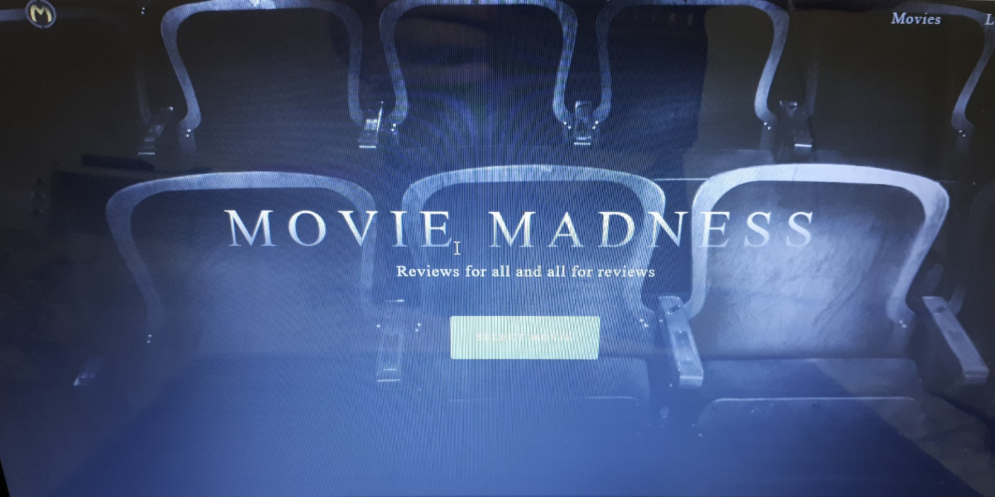2.2

Highlights the title of the website in bold, clear lettering to draw in the end user.

Onclick event handled to allow the end users to select a movie they wish to analyse in terms of review, rating and summary.

2.3

**Project scheduling**

In order to ensure that our project was completed within the 2 weeks deadline, we undertook thorough project management of a project planning chart so that our project manager could monitor us and help us when required and we could help each other, to ensure each task was completed to a high quality standard.



In addition to this, trello was used in order to ensure that the project criteria was broken down, allowing each member of the team to work together and be involved in the task equally.

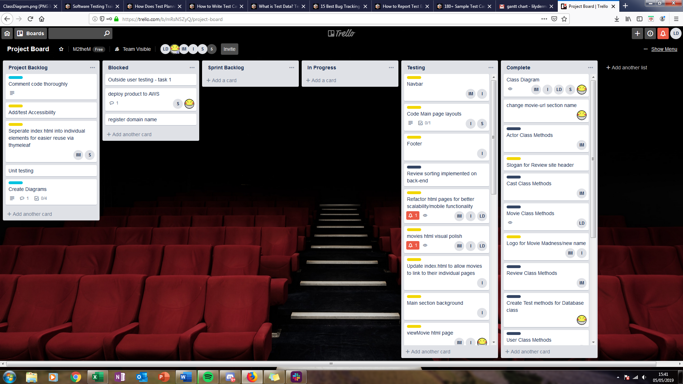

* 1. Data Modelling

In order to allow for clear and readable yet secure code, a class diagram was constructed as part of the project beginning. Access modifiers were given public to enable different classes to implement variables and their methods specifically, which were not sensitive or personal data.

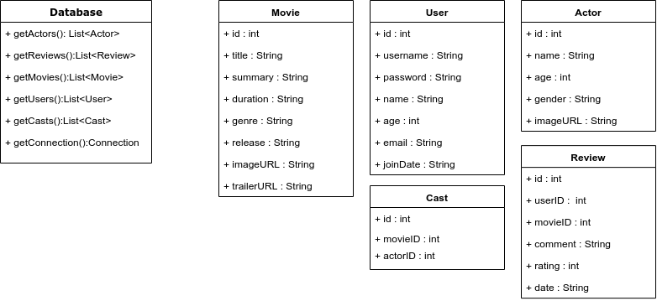

3. project testing

3.1 In order to ensure that code was fully executable and all the links were working, thorough testing was carried out. Below will state the three test cases that were consistently tested throughout the duration of this project

3.2.1 Testing of user event handlers aka buttons in javascript

3.2.2 Tests to ensure that the java code was working such as the sorting and connection to the database.

3.2.3 tests to check the style of the website was clear and attractive.

In order to ensure these tests objectives were met, we carried out onclicks and refreshed the browser using localhost:8080 specifying the port number through which the project should run. As well as this, breakpoints were added in the java code to ensure that code could be easily debugged and front end code was commented to ensure that any moderations could be clear to find and simplistic to implement.

4. Project Evaluation

4.1 In conclusion, the projected was fully created and finished in relation to the deadline and in an agile fashion as set out.

4.2 Delivering a clear user interface for our end users – This objective was met as the website produced includes clickable features, and each page is labelled with meaning allowing for easy navigation and colouring does not clash.

Fully working code with rapid user interaction for our end users- This object has been fully met as clickable features and sorting by reviews had been added to allow our end users to view the content.

Clear and clean code for our end users – code has been fully commented so that the end users can analyse what is going on behind the program to minimise abstraction.

Efficient and secure code produced – only code can be accessed by the github users (makers of the project). To prevent external users modifying the code and causing corruptions to the project output.

4.3 further enhancements:

Deploying the project into aws to demonstrate our skills would have been enjoyable to have completed in the time given. However, the 7 month trial would have expired and we would not have had sufficient budgets to keep the implementation, although we have exposure to aws so understand how it can be implemented and are looking forward to using it in the future.

A login sector could have been added to the project, but we decided that it was important to finish off the main aspects of the project in the time given due to the shorter deadline at a high quality, as implementing this could have had a detrimental impact on the rest of the project.

* 1. end user feedback:

1. Are there any ways in which we could improve our project for you overall?
2. Based on our project, do you feel that the overall project is simplistic to use?
3. How do you feel about the quality of the webpage?